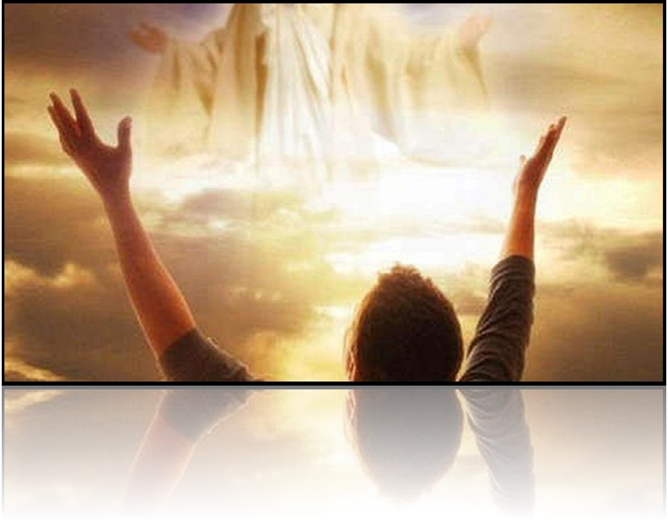
The Life that Looks Up to Christ
Colossians 3:1-4

Introduction:

As is Paul’s custom, he divides Colossians into doctrine and practice. We can illustrate that custom with the Epistle to the Romans.

1. Righteousness Needed - Condemnation – 1-3:20
2. Righteousness Imputed - Salvation - 3:21- 5:21
3. Righteousness Imparted - Sanctification – 6:1- 8:39
4. Righteousness Vindicated - Dispensation – 9-11
5. Righteous Practiced - Application – 12-16

In 12:1 he writes: “I ﻿﻿beseech ﻿﻿you therefore, brethren”. The wording in Colossians 3:1 is similar to Romans 12:1 - “I therefore οὖν beseech you”.

The key word is “therefore” οὖν. Paul has given the doctrinal part in the first 2 chapters. Now, beginning in chapter 3, he tells us what we should do about that doctrine we have just learned.

Dr. Charles Ryrie used to say (probably still does), “All doctrine should be practical. All practice should be doctrinal.”

In these two “practical” chapters you would expect to find commands – and we do: There are 16 imperatives (commands) in chapter 3. There are 9 imperatives (commands) in Chapter 4. That is a total of 25 commands in two chapters {four more in chap. 1-2}

Paul starts this section with the word, οὖν meaning “therefore,” implying that what is said here follows logically from the previous section, either the paragraph, or more likely the entire first two chapters.

I. Requirement – 3:1a

“If then you were ﻿﻿raised with Christ” – “υἱὸς τοῦ θεοῦ”

The word “If”, in this case should be translated “since” [“Since then” NIV]. He is telling them that they should obey all 25 of these commands in chapters 3 and 4. That’s what the Christian life should look like.

Wherever this message is preached, every listener needs to ask himself, “Have I been raised with Christ?” “Do I believe that Jesus is the Christ, the Son of the living God (John 20:30-31) and the promise He gives that the one who believes on Him has eternal (never ending) life (John 3:16)? Because: You can’t live the Christian life until you have the Christian life to live.

Paul is assuming that they were raised with Christ. (And is basing his further comments on that assumption.) In the case of the Colossians, it is also true in reality. We know that from (2:12) where Paul said that they had, “been buried with Him in baptism, in which” they, “were also raised up with Him through faith in the working of God, who raised Him from the dead.”

We learned there that Paul is referring to new birth (which is PICTURED in water baptism). At the moment they became spiritually alive, His life became their life. Prior to their “new birth,”

They were, “dead in your trespasses and the uncircumcision of your flesh…” (2:14), they had no relationship with God. At the moment of their belief in Jesus Christ, they do have a relationship with God. They are no longer a part of this world-system. There are citizens of the higher realm. So Paul’s first command to them is:

II. The Responsibilities – 3:1b-2

A. Seek – 3:1b

“seek those things which are above, “ -- Literally: “the things above keep seeking”

The tense of the verb indicates that this is to be an “on-going” process. “Keep seeking” is the idea. Your Savior is above, your home is above, your future is above and you are not of this present evil world, though we shall return with Him.

“at the right hand of God.”

The word “hand” is obviously intended. There are approximately 20 places where Christ is said to be on the right “hand of God: Many are based on the Old Testament passage, Psalm 110:1,

“The ﻿﻿Lord said to my Lord, “Sit at My right hand, till I make Your enemies Your ﻿﻿footstool.”

This verse may be the most quoted O.T. verse in the N.T. It is common, but it is very important. The natural desire is to be where He is and according to His promise Jesus is making arrangements (the New Jerusalem) for that to be the case right now, “I go to prepare a place for you, that where I am you may be also” (John 14:2) Because that is going to be the case, we should be preparing for that event now.

The right hand is the place of privilege and authority. Believers are seated with Him in the heavenlies. (Eph.1:3, 20). We should remember also that there is a heavenly city to seek, in Hebrews. After saying, “you have not come to Mt. Sinai.” The writer (Luke) says:

“But you have come to Mount Zion and to the city of the living God, the heavenly Jerusalem, to an innumerable company of angels, to the ﻿﻿general assembly and church of ﻿﻿the firstborn ﻿﻿who are registered in heaven, to God ﻿﻿the Judge of all, to the spirits of just men ﻿﻿made perfect, to Jesus ﻿﻿the Mediator of the new covenant, (Hebrews 12:22-24)

How would you fit in with that crowd? The Jerusalem below is getting quite a bit of news coverage now. The Jerusalem above will be the entire News cast, 24/7 – if there was any reference to time-

The second command is to,

B. Set your Mind – 3:2

1. The Positive Side – 3:2a

“on things above,”

Paul has shifted his emphasis from your will to your mind. This is the idea behind Phil. 4: 8,
“Finally, brethren, whatever things are ﻿﻿true, whatever things are ﻿﻿noble, whatever things are ﻿﻿just, ﻿﻿whatever things are pure, whatever things are ﻿﻿lovely, whatever things are of good report, if there is any virtue and if there is anything praiseworthy—meditate on these things.”

The things above were given in chapter 2

- The ransoming and remission of sins (2:14).
- The treasure of wisdom and knowledge hidden away (2:3)
- All that He, as the head, supplies to make it grow with the growth of God (2:19)

We can define “the things above” by the contrast “with the things below.”

2. The Negative Side – 3:2b

“not on things on the ﻿﻿earth.”

The Judaizers stressed the earthly things as though they could cause a believer to lose, or fail to find, his life in Christ. Paul is saying, “In Christ you have life and cannot lose it. Now concentrate on growing in and glorifying Christ with that life.

III. The Reason – 3:3

A. You Died – 3:3a

“For you died,”

“for” because you are dead to the things of the world. The things of the world, the things of the Judaizers:

- Religious philosophy (2:8)
- Manner of worship (2:18,23)
- Decreeing (2:20-21)

These are all plain and visible. They are to keep on minding the things above which are spiritual and invisible.

They have died “away from” the elemental things of the world. (2:20), you got away from every bit of religion that operates with material things and with doing this or that with them.

What does it matter to a dead man what anyone does with material, earthly things? But this death gave us life through our resurrection with Christ. The Judaizers know nothing about this life It’s invisible – they deal in the visible realm.

B. Your Life Is Hidden – 3:3b

“and your life is hidden with Christ in God.”

God raised up Christ to a life of infinite glory and He raised us up with Him. The idea of hidden implies both concealment and safety. We have been resurrected positionally. So, it is invisible yet secure,

1 John 3:2
“Beloved, ﻿﻿now we are children of God; and ﻿﻿it has not yet been revealed what we shall be, but we know that when He is revealed, ﻿﻿we shall be like Him, for ﻿﻿we shall see Him as He is.”

IV. The Reward – 3:4

A. The Timing of the Reward – 3:4a

“When Christ who is ﻿﻿our life appears,”

We are in line for a reward, it is promised and certain. But when will it come? At the rapture of the Church (1 Thess.4:13; 1 Cor.15:51).

Christ, our life (Phil 2:21), is now invisible and our life with Him is invisible. He is going to become visible. At that point, our life shall be made visible.

Both John and Paul use the same verb φανερόω - and in the passive. When He is “made to appear” we also will be “made to appear.”

B. The Type of the Reward – 3:4b

“then you also will appear with Him in ﻿﻿glory.”

Question: But where is the reward?

We know from other scriptures that this “appearance” is the time of the rewards. But those crowns and honors will fade in the light of His glory.

Emmanuel’s Land

The bride eyes not her garment,
But her dear Bridegroom’s face;
I will not gaze at glory
But on my King of grace.
Not at the crown He giveth
But on His pierced hand;
The Lamb is all the glory
Of Emmanuel’s land.

Conclusion:

The commands of Colossians are just beginning. Remember? There are 25 commands in Chapters 3 and 4. He will get more specific as he goes along. For now, he says,

- Set your heart on things above. This stresses striving.
- Set your mind on things above. This stresses concentrating.

